Science 9 – Course Outline
Name: ________________________________ Date: _______________________

General Information
Mr H. Buhl (6RP)  Email: buhl_h@surreyschools.ca  (email is preferred)  Johnston Heights Phone: 604-581-5500  Websites: buhl.yolasite.com  Microsoft Teams (Download Microsoft teams app and use your school email to sign in) | 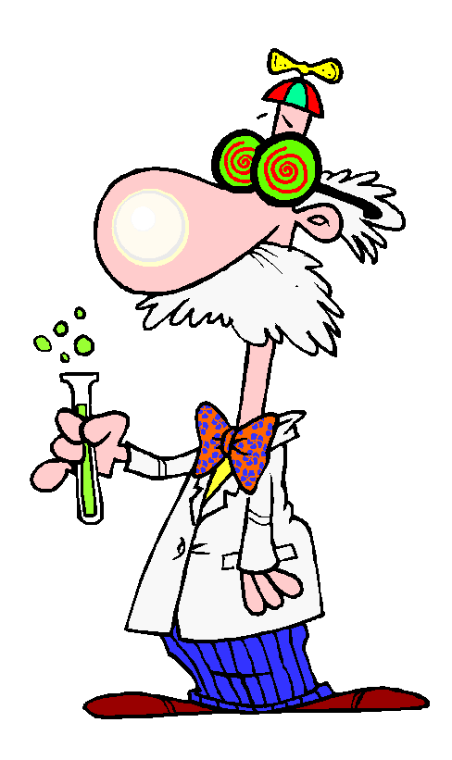  Textbook: BC Science Probe 9 Text and Workbook  Daily Supplies Required:  2 inch Binder, dividers, lined paper, pencil, pen, eraser, scientific calculator  Previous Student Recommended:  Coloured pens / pencil crayons, glue stick, ruler, USB flash drive (for printing in the Learning Commons)

Class Code of Conduct
Every teacher has his or her own set of classroom expectations (some people call them rules). This is not meant to make life more difficult or less fun, but to ensure that you are able to work to the very best of your ability and that all students are graded fairly in this course. The following are the expectations for this class:
Teacher is expected to:  - provide hands-on learning activities, and/or use technology when possible  - assign homework and assignments that have a purpose  - turn off digital device during class | Students are expected to:  - Come to class everyday prepared & on time  - turn off digital device during class (unless told otherwise)  - treat peers & learning environment respectfully  - not bring food/drink (bottled water is allowed)  - Complete and participate in activities & learning experiences in class, and finish for homework if not done in class.

Evaluation: Criterion
You will be marked on each of the four MYP Criteria per course, on the 1-8 scale. Assignments will always be clearly labelled with the criteria being assessed, along with specific descriptions of the task at each level. You must meet all the requirements of the earlier level, for your work to be considered at the next highest level, and so on. Each criteria achievement is considered equally, to determine your overall mark and level of achievement:
Science:
Criterion A: Knowledge & Understanding
Criterion B: Inquiring & Designing
Criterion C: Processing & Evaluating
Criterion D: Reflecting on the Impacts of Science
You are responsible for tracking your results and scores on sheets provided. This way you always know where you’re at!! Remember, your goal is not to score highly on as many items as you can, but to GROW your learning throughout the year, and learn and improve each time!

Evaluation: Approaches to Learning
You will also be tracking your strengths in different areas of self-management, communication and thinking. ATL’s will be updated on a regular basis, with each item on the provided tracking sheet having at least one example/demonstration and a goal.

Course Overview
SCIENCE 9 BIG IDEAS
- Cells are derived from cells
- The electron arrangement of atoms impacts their chemical nature.
- Electric current is the flow of electric charges.
- The biosphere, geosphere, hydrosphere, and atmosphere are interconnected, as matter cycles and energy flows through them.

TIPS FOR SUCCESS!
1. REVIEW material nightly in addition to studying for tests and working on assignments.
2.. Ask questions and PARTICIPATE in class discussions.
3. Complete ALL assignments to the best of your ability.
4. Keep your notebook NEAT and tidy so you can easily find information when you are reviewing.
5. If something doesn’t make sense, ASK! If you need help, please come see me or email me anytime.

Student name (Print Please): ________________________________________________
Student signature: _______________________________ Date: _______________________

